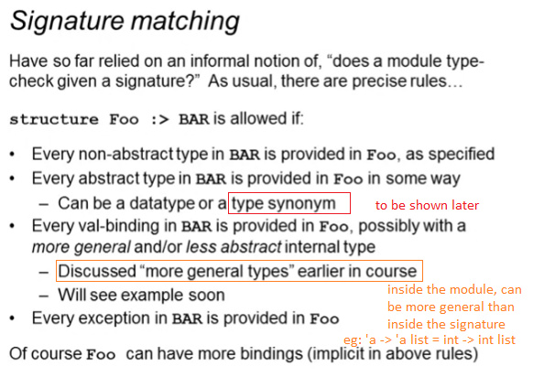

* Inside the module
  + More general functions
    - ‘a -> ‘a list
  + No abstract types, must have the definition of type
    - datatype rational = Whole of int | Frac of int \* int
  + Can have bindings that is not mentioned in the signature
* Inside the signature
  + More specific functions
    - int -> int list
  + Abstract types are allowed
    - type rational
  + Cannot have bindings that is not mentioned in the module